**Online Geolocation-based Mobile Tracking System for Herbal Plants**

A Capstone Project

Presented to the IT

Faculty of

Pangasinan State University San Carlos Campus

In Partial Fulfilment of

The Requirements for the Degree

of Bachelor of Science in Information

Technology

Calugay, Rhea D.

Castro, Agnes D.

Fernandez, Dan Merick DG.

2022

**TABLE OF CONTENTS**

COVER PAGE Pages

**TITLE PAGE**

**APPROVAL SHEET** ……………………………………………………………………………

TABLE OF CONTENTS……….……………………………………………….......................

**Chapter 1**

**INTRODUCTION**

1.1 Project Context………… ……………………………………………………………

1.2 Purpose and Description……………………………………………………………

1.3 Objectives of the Project ……………………………………………………………

1.4 Significance of the Project …………………………………………….……………

1.5 Scope and Limitations …………………………………………….……………….

**Chapter 2**

**REVIEW OF RELATED LITERATURE AND SYSTEMS**

2.1. Technical Background ………………………………………….……………….

2.2. Review of Related Literature/ Systems …………………………………………

2.1.1. Related Literature……………………………………………………….

2.1.2. Related Studies …………………………………………………………

2.1.3. Summary of Related Literature…………………………………………….

2.3. Synthesis…………………………………………………………………………...

2.4. Conceptual Framework………………………………………………………….

2.5. Definition of Terms.……………………………………………………………….

Chapter 3

METHODOLOGY

3.1. Methods…………………………………………………………………………….

3.2. Requirement Analysis…………………………………………………………….

3.2.1 Population and locale of the study………………………………………

3.2.2. Data Instrumentation……………………………………………………

3.3. Data Analysis……………………………………………………………………….

3.4. Description of Prototype…………………………………………………………..

35. The Proposed Implementation Plan ……………………………………………..

**CHAPTER 1**

**INTRODUCTION**

**1.1 Context of the Project**

Mobile phones have become an essential part of human life. Teenagers are most mobile phone users in the world. Mobile phones are considered a necessity nowadays. It’s a powerful form of communication. It represents functionality and style in one small package. Billions of people worldwide are now owners of cell phones. Smartphones helped people become connected to the internet 24-7. Since the internet is highly addictive, many people are motivated to own a smartphone. Applications extended the functionality of smartphones, thus making almost everything possible. Because of mobile devices, kids and teens today are more technologically advanced, and can find solutions to situations which would have otherwise been difficult (L Srivastava, 2016).

Before smartphones and tablets were a thing, websites were created to display on laptop and desktop computers. The designs of such websites were unresponsive, which means they did not naturally scale to different screen sizes and were difficult to view and use on smaller screens. This was not problematic at first, because no one was trying to view websites on smartphones or tablets. Once mobile devices became popular, though, the disadvantages of these website designs became clear. Then, mobile applications emerged, and existing websites created mobile versions of their sites so users could easily view them on the go and use them with touchscreen devices. For some time, apps, websites, and mobile websites all existed in separate buckets, but now they are becoming the norm (Kevin Nicholas, 2014).

Apart from allowing users to interact with the world, mobile apps can be used for advertising, lifestyle, utility, news, educational purposes, games entertainment.

Through Online Geolocation-based Mobile Tracking System for herbal Plants it will help users to access information on potential safety problems, side effects, and herb-drug interactions with additional links to resources for more information. They can also mark favorite herbs for quick recall and online accessibility. Geolocation-based Mobile Tracking System for herbal Plants will provide only scientific, research-driven information. Medicinal plants play vital roles in disease prevention and their promotion and use fit into all existing prevention strategies. However, conscious efforts need to be made to properly identify, recognize, and position medicinal plants in the design and implementation of these strategies. These approaches present interesting and emerging perspectives in the field of medicinal plants. Recommendations are proposed for strategizing the future role and place for medicinal plants in disease prevention.

According to M. Ekor (2013), today, we live in a time when manufactured medicines and prescriptions prevail. Herbal remedies that can heal and boost physical and mental well-being. A lot of alternative medicines aren’t cure-alls, and they aren’t perfect. Many carry the same risks and side effects as manufactured medicines. Many of them are sold with unfounded promises. Plants have been used for centuries for many different and innumerable uses including its vital role in the therapeutic world wherein the medicinal properties it contains are very beneficial. Some of the several advantages of traditional medicine include being affordable and easy to access. Plants that are classified as herbal are processed and made into medicines or it can be freshly picked and boiled. They are used for therapies and common illnesses such as cough, colds, and allergies. Medicinal plants are considered as a rich resource of ingredients which can be used in drug development of either pharmacopeial, non-pharmacopeial or synthetic drugs. Apart from that, these plants play a critical role in the development of human cultures around the whole world.

According to the World Health Organization (WHO) Expert Group defined Traditional Medicine as the sum of all knowledge and practices, medicinal plant is any plant which, in one or more of its organs, contains substances that can be used for therapeutic purposes, or which are precursors for the synthesis of useful drugs.

Plants are very important in the field. Plants are a great source of medicine even for life-threatening disease. It can even notice that plants are the sole sources of the medicines for few life-threatening ones too. Plant medicines are safer due to their lower chances of side effects and better compatibility to humans. According to the World Health Organization (WHO) a vast majority of people (about 80%) in the developing world relies on herbal medicines for their primary healthcare needs (A. Sofowora, 2017). To easily find natural medicine, we were going to use geolocation. A geolocation is use of location technologies such as GPS or IP addresses to identify and track the whereabouts of connected electronic devices. Because these devices are often carried on an individual's person, geolocation is often used to track the movements and location of people and surveillance. Geolocation makes it possible, from any device connected to the Internet, to obtain all types of information in real time and locate the user with pinpoint accuracy at a given point in time. Geolocation technology is the foundation for location-positioning services and location-aware applications.

Some medicinal plants can be found in several places, including on community lands, either planted or grown wild. By using geolocation in our mobile application, it can easily find the nearest medicinal plants and determine the shortest path to reach the nearest location of it. The proposed solution will help the users find medicinal plant locations on a map. The location of medicinal plants' geographical distribution is helpful to conservation of the habitats themselves and to let people know and observe how much they still value the cultivation of medicinal plants.

**1.2 Purpose and Description**

The city health office (CHO) provides medical, dental, and nursing services to the constituents of the city, provides information services on health and sanitation, and ensures that these are enforced. As related in our title " Online Geolocation-based Mobile Tracking System for Herbal Plants” the city health office San Carlos and by the help of Dr. Edwin DV. Guinto, the city health office is willing to help and guide us in our project by stating their needs as a doctor and specify the needs of their patients. To easily locate natural plants, the city health office stated possible barangays who have planted natural medicines. The city health office is the one who maintains the proposed project.

**1.3 Objectives of the Project**

This research aims to design and develop “Online Geolocation-based Mobile Tracking System for herbal Plants” Specifically, it aims to answer the following objectives.

• To provide information about natural medicine for health.

• To recognize the different kinds of herbal plants and its uses as natural medicine.

• To assist users, find herbal plants using this application.

• To give objective information backed by scientific references.

• To easily locate the needed herbal plants using geolocation.

• To save and mark all favorite herbal plants and explore features of application.

• To be able to maintain the natural way of medicine.

• Understand how herbal plants help the medical industry.

**1.4 Significance of the Study**

This study was made with the aim to develop an Online Geolocation-based Mobile Tracking System for Herbal Plants for the City Health Office in San Carlos City, Pangasinan. This study was significant in providing a Mobile application as a mechanism to provide a fastest way of searching Herbal plants in the City of San Carlos.

The implementation of Online Geolocation-based Mobile Tracking System for Herbal Plants is intended to provide great help and will be beneficial to the following entities:

**City Health Office**. This project is a great contribution to the City health office especially for the doctors and other staff. This project will be their guide to help their patients and give advice to use and maintain natural medicine for those patients who don’t have enough money to buy medicine.

**User.** This mobile application will provide information for users which are the patients, students, and many more to encourage them to plant and maintain medicinal plants. This Mobile application helps them to easily locate the availability of herbal plants they need and for them to know more about herbal plants.

**Future Researcher.** The result of this project will be a reference to the next researcher who will be going to accomplish this kind of research.

**1.5 Scope and Limitation**

The focus of this proposed project entitled “Online Geolocation-based Mobile Tracking System for Herbal Plants”. This application is expected to:

**Scope**

1. Provide reliable information about medicinal plants.

2. Provide all medicinal plants based on DOH approved, the uses of each medicinal plants, their scientific names including the pictures of each medicinal plant.

3. It can also mark and save the favorite features of medicinal plants.

4. Everyone can access the application.

5. There is no limitation in adding favorites.

6. The users will easily get notification to the chosen location of herbal plants.

**Limitation**

1. This project is applicable only when you have an internet connection.

2. The specific admin only can update the application.

3. Only the DOH approved are stated in the application.

4. Only the given location of the application can find the herbal plants.

The city health office (CHO) provides medical, dental, and nursing services to the constituents of the city, provides information services on health and sanitation, and ensures that these are enforced. As related in our title " Online Geolocation-based Mobile Tracking System for Herbal Plants” the city health office San Carlos and by the help of Dr. Edwin DV. Guinto, the city health office is willing to help and guide us in our project by stating their needs as a doctor and specify the needs of their patients. To easily locate natural plants, the city health office stated possible barangays who have planted natural medicines.

**CHAPTER 2**

**REVIEW OF RELATED LITERATURES AND SYSTEMS**

**2.1 Technical Background**

In this chapter we discuss the technology that we are about to use and the explanation for all those technical developments for the proposed system. It includes the hardware and software requirements, specifications, and programming language that will be used. The hardware specification refers to the main needed in the implementation of the system while the software specification refers to the application software used in the development of the system.

Hardware Requirements for the System Development

| Hardware | Specifications |
| --- | --- |
| Processor | Intel Core I5 |
| Memory | 4GB |
| Hard Disk | HDD 1TB |
| Storage | 300GB |

In this table it shows the hardware requirements used during the development of the project. It includes the specifications: the processor, memory, hard disk and storage.

**Processor.** An integrated electronic circuit that performs the calculations that run a computer. A processor performs arithmetical, logical, input/output (I/O) and other basic instructions that are passed from an operating system (OS). Most other processes are dependent on the operations of a processor.

**Memory.** Is just like a human brain. It is used to store data and instructions. Computer memory is the storage space in the computer, where data is to be processed and instructions required for processing are stored.

**Hard disk.** Also called hard disk drive or hard drive, magnetic storage medium for a computer. Hard disks are flat circular plates made of aluminum or glass and coated with a magnetic material.

**Storage.** The component of your computer that allows you to store and access data on a long-term basis. Usually, storage comes in the form of a solid-state drive, or a hard drive can refer to both the stored data and to the integrated hardware and software systems used to capture, manage, secure and prioritize that data.

Software Requirements for the System Development

| SOFTWARE | SPECIFICATIONS |
| --- | --- |
| Operating System | Windows 10 |
| Web Server | Xampp |
| Database Management | MySQL |
| Android Studio | IDE Emulator |

In this table define the software requirements used in the development of the project such as Windows10 for Operating System, Xampp for Web Server, MySQL for Database Management System and Google Chrome for Web browser.

**Operating system.** The most important software that runs on a computer. It manages the computer's memory and processes, as well as all of its software and hardware. It also allows you to communicate with the computer without knowing how to speak the computer's language.

**Web server.** A computer that runs websites. It's a computer program that distributes web pages as they are requisitioned. The basic objective of the web server is to store, process and deliver web pages to the users.

**Database Management.** Allows a person to organize, store, and retrieve data from a computer. Database Management can also describe the data storage, operations, and security practices of a database administrator (DBA) throughout the life cycle of the data.

**Web browser.** A software program that allows a user to locate, access, and display web pages. In common usage, a web browser is usually shortened to "browser."

**Android Studio.** A software program that allows a user to build apps for Android phones, tablets, Android Wear, Android TV, and Android Auto. Structured code modules allow you to divide your project into units of functionality that you can independently build, test, and debug.

**Software used in the system:**

**Flutter**

Flutter is Google's portable UI toolkit for crafting beautiful, natively compiled applications for mobile, web, and desktop from a single codebase. Flutter works with existing code, is used by developers and organizations around the world, and is free and open source.

**PHP**

PHP (recursive acronym for PHP: Hypertext Preprocessor) is a widely used open-source general-purpose scripting language that is especially suited for web development and can use backend in Flutter as Rest API which provides endpoint that can be hit in Flutter Application and could return response in JSON or XML format from PHP REST API which can be manipulated at the application front-end with flutter.

**MySQL**

MySQL is an open-source relational database management system. As with other relational databases, MySQL stores data in tables made up of rows and columns. Users can define, manipulate, control, and query data using Structured Query Language, more commonly known as SQL.

**XAMPP**

XAMPP is one of the widely used cross-platform web servers, which helps developers to create and test their programs on a local webserver. It’s a cross-platform web server that is free and open-source. XAMPP is a short form for Cross-Platform, Apache, MySQL, PHP, and Perl.

**2.2 Review of Related Literature / System**

This chapter contains review of related literature and studies which have added further knowledge on the study that the developers utilize to evaluate the current investigation. The developers highlighted some comparable literature as well as local investigations conducted by several researchers that are very similar to the current study. Also, this chapter covers the Synthesis that encountered in the study.

**2.1.1 Related Literature**

There had been several attempts to facilitate the search and accessibility of medicinal plants since they are the key ingredients in indigenous medicine. The Department of the Philippines approved ten Medicinal Plants, after they have been scientifically validated to ensure safety and efficacy. These are Acapulco, Ampalaya (Makiling variety), Lagundi (five leaflets), Bawang, Bayabas, Sambong, Niyog-niyogan, Tsaang-gubat, Yerba Buena, and Ulasimang bato (pansit-pansitan).

In the article of A.C SAS entitled “Plants and Health” he stated that man is wholly dependent upon plants. Plants also means to preserve health and recover from sickness. The early 90’s seemed hopeful for the merging of western and alternative medicine in the Philippines. There was a burgeoning global movement towards alternative therapies, a new-age allure for “natural” remedies. In the Philippines where herbal plant species abound, it is customary for Filipinos to use them in nursing minor illnesses such as cough, colds, flu, infections, and other skin infections. Though there are still many Pinoys who still question the efficacy of these plants, medical research and studies have already acknowledged their value in the world of medicine. Following the establishment of the efficacy of these herbal medicines in the Philippines, the Department of Health (DOH) and Department of Science and Technology (DOST) have released their recommended list of herbal plants found in the Philippines and the health benefits they provide, further concretizing the role of alternative medicine in medical practice. In 1992, during the term of Juan Flavier as a Secretary of Health, a brochure of 10 medicinal plants (akapulko, ampalaya, bawang, bayabas, lagundi, niyog-niyogan, pansit-pansitan, sambong, tsaang-gubat, yerba buena) for common health problem was published and commercial production was pursued. In 1997, the TAMA (Traditional and Alternative Medicine Act) was passed, providing a legitimizing boost to the alternative medicine movement in the Philippines.

Yet nature has many plants to offer to cure any diseases, there came the new inventions of different scientists and as time passed healing plants are replaced by new sets of medicinal plants are replaced by new sets of medicinal drugs that affects easily without passing through many processes unlike with the use of plants.

Just like what Mr. Benigno has stated in his Journal entitled the use of complementary and alternative medicine (CAM) in a conventionally western-oriented medical practice in the Philippines. There is an ongoing romance between the West and East regarding medicine to offer a more holistic approach with as many options as acceptable when both forms of treatment are combined. There is a great promise when one looks back in the early beginnings of western medicine, reliance on the use of medicinal herbs were the forebears from which the active form of drugs has been isolated and formulated. But as a situation here in the Philippines affording prescription drugs is not that easy especially for those in rural areas. That’s why they prefer using alternative medicine without assurance if it would really cure their diseases.

Medicinal Plants have been used from antiquated times to Endeavour cures for several diseases and to relieve physical suffering. Antiquated people all had some knowledge of medicinal plants and their functional properties (Nazim et al., 2017). Before the advent of formal medicine, people largely depended on herbal plant knowledge that has been passed through generations of families. From poultices for wounds and bruises to tinctures and concentrated oils for disease treatments, herbal medicine has been around since time immemorial.

Today, mobile apps render a good platform for business, banking, education, reading etc. According to Danish (2020) medicinal plants application design to develop a software to disseminate, familiarize the medicinal plants and to help the users to find medicinal plants. Medicinal plants will plant in the community to treat existing sickness, and to identify and classify these plants according to their uses. Medicinal plants sprawled and grew in the community be it herbs, shrubs, trees, or any other species.

According to Satyaputra & Aritonang (2018), Android is a system which existed on tablets and smartphones. The illustration on this system is as a bridge which connects users to interact with their devices and can operate or run applications available on the device. Mobile apps are important in today's world. In recent years, with the rapid growth in technology, mobile phones have become a vital part of human life. Even though mobile phones’ core function is telecommunication, now mobile apps have made many things possible which were previously unimaginable. Years before two-three families together shared a single phone. But now the things have changed with the upcoming of smartphones, each person today owns their own mobile phones. The main advantage of mobile phones is its portability, you can carry them in your pockets wherever you go. With the booming of internet and e-commerce, more and more enterprises are publishing their product information on the web. By visiting the web through the Internet, users can view the product and if the users are satisfied with the products and prices, they may order them online on the spot. Because this application has never existed before, the researchers decided to make this application for smart phone-based Android Operating System.

According to Yuhefizar (2018), an application is a program that was developed to meet the needs of users in carrying out certain jobs. The software is made to speed up the work process in processing various kinds of data into information needed by its users.

According to Reynold (2017), they develop a new herbal medicine online order by implementing code and combining it into one Android application. The idea is using the Android device to process the input and match the right herbal medicine for each disease. To determine the right herbal medicine for each disease, this application can match automatically according to the data input from the user. This application is an application to order herbal medicine for each user's disease. Users can geotag the location of native plants, learn the plants’ native names, and read about how native plants have been used for thousands of years. Geotagging involves the user creating a geographic point in the map interface of the application that will represent the native plant of their choice. An enterprise geodatabase was created using Esri ArcGIS 10.1 for Server to store the native plant data and allow multiple users to create and edit their own geotags of native plants.

There are many scientific studies that could benefit from knowing the location of users posted the medicinal plants (Batcheler). Researchers can track the distribution of native plants that have been recently restored in places where they once disappeared (Serrill 2017), and medical professionals can study and locate various native plants that may help them create new medicines to treat diseases.

According to Wikipedia, Geo location is when GPS can locate you by identifying your geographical location via satellite and allows you to post your physical location on any social networking site. When your location is shared online, and you regularly sign or tag yourself into the same place at the same time. Commonly used examples of location based services include navigation software, [social networking services](https://en.wikipedia.org/wiki/Social_networking_services), [location-based advertising](https://en.wikipedia.org/wiki/Location-based_advertising), and [tracking systems](https://en.wikipedia.org/wiki/Tracking_systems). Location-based services (LBS) are widely used in many 21st Century computer systems and applications. Modern location based services are made possible by technological developments such as the [World Wide Web](https://en.wikipedia.org/wiki/World_Wide_Web), [Global Positioning Systems](https://en.wikipedia.org/wiki/Global_Positioning_System), and the widespread use of [mobile phones](https://en.wikipedia.org/wiki/Mobile_phones).

**2.1.2 Related Studies**

**Foreign**

[Medicinal Plants](https://www.sciencedirect.com/topics/computer-science/medicinal-plant) are nature's precious gift that has a long empirical history of healing diseases with relatively no or less side effects. Since ancient days several studies have been performed to identify the therapeutic values of those plants. It includes analysis of their chemical constituents as these chemicals play vital role in regulating biological activities in human body that cause diseases. These days all those sincere efforts have coined a new term “Alternative Medicine” which stands on the idea of using plants for medical purpose. One of the main streams of traditional medicine is herbal medicine; a wide range of medicinal plants and their individual parts are used for therapy, Umar Zein (2017).  Herbal medicine is a popular treatment method for a wide range of diseases in many countries due to its claims of therapeutic activity by patients. The knowledge handed over from generation to generation since ancient ages is the foundation of traditional medicine; hence, the methods of treatment vary depending on the country and the region of origin. In addition, a single region may use different types of traditional medicine due to different ethnic backgrounds of its citizens migrated from different regions of the world.

Herbal medicine is a medicine made from natural ingredients traditionally. This drug is a prescription-based ancestor or has existed since time immemorial. These drugs are still many made or used to treat various diseases. According to the research, herbal medicines are beneficial to health and now intensified in use because they are easier to reach by the people, both price, and availability. Apart from that, people would consume any medicine that is recommended by others to gain good health, yet they are not aware about the contents of the medicine whether it is safe to use or not. There are a lot of products in the market that contain dangerous ingredients which may cause harm to the human body. Herbal medicine is one of the great ways to gain good health.

In recent years, more attention has been paid on natural products, and the importance of the herbal medicine's research and development; the medical products have been realized by the international society. The herbal medicine industry plays a critical role in ensuring a country's continuous development as its function is to provide the healthcare needs to communities and individuals and impacts the life of every person. Moreover, as one of the largest and fast-growing industries, together with several other service industries, e.g., transportation, financial services, and data processing, accounts for more than half of all projected job growth over the coming decade. However, most governments in developed economies are cutting down the public healthcare spending; the healthcare costs are rising as a result of, e.g., the advancement in medical technologies, the change of healthcare cost structures, the incidents, such as deaths and injuries in hospitals, and other healthcare service quality problems are often reported. All these pressures force herbal medicine industries to develop (or redesign) their services such that the expected healthcare can be delivered with the available resources.

Meanwhile, with the rapid progress of communication and information technology and their extensive application in traditional industries, the modernization and internationalization of these industries have been accelerated. Modern information technology has become the opportunity for the development of herbal medicine online order. Taking the advantage of source sharing, and the easy acceptance of the information, the information technology has been widely used in the whole herbal medicine industry.

According to Hanifuddin (2017), the introduction application of medicinal plants is very widely applied to Android-based gadgets because this communication device is most widely used by the public, so the introduction application of medicinal plants aims to provide information about the benefits of medicinal plants. Therefore, in the modern era, the role of cultivators is important to preserve these medicinal plants. The existence of technology which is developing in the modern era requires an application which can provide information and uses of certain 60 medicinal plants so that it can make it easier for the public to access them.

In Thailand, the Ministry of Public Health promotes the use of medicinal plants in the community as a means of relieving symptoms, complementary to modern medicine (Ochwang’i et al., [2017](https://geospatialhealth.net/index.php/gh/article/view/998/1012)). Such plants have been used for manufacturing herbal medicines, instant food and beverages and cosmetics. Medicinal plant information systems can be categorized according to two foci: i) retrieval of data on therapeutic use; and ii) development of herbal plant database applications. The former includes creation of knowledge bases matching diseases with their herbal remedies (Ogirima, [2015](https://geospatialhealth.net/index.php/gh/article/view/998/1012); Tungkwampian et al., [2015](https://geospatialhealth.net/index.php/gh/article/view/998/1012); Fausat et al., [2019](https://geospatialhealth.net/index.php/gh/article/view/998/1012)). For instance, users can look up plant names, their medicinal properties, their use for curing diseases and other relevant details, e.g. suitable climates for plantation or ontology techniques in designing a database for therapeutic information retrieval (Tungkwampian et al., [2015](https://geospatialhealth.net/index.php/gh/article/view/998/1012)). Later developments of online software packages have proposed herbal plant information management web applications managing names of herbs, their medicinal properties and images overcoming previous limitations that only allowed authorized access to data management functions (Mary et al., [2012](https://geospatialhealth.net/index.php/gh/article/view/998/1012)).

**Local**

As the World Health Organization (WHO) defines ‘Traditional medicine is the sum of the knowledge, skills, and practices based on the theories, beliefs, and experiences indigenous to different cultures, whether explicable or not, used in the maintenance of health as well as in the prevention, diagnosis, improvement or treatment of physical and mental illness. Herbal medicine is one of the main streams of every traditional medicine practice. In the Philippines, more than 1500 medicinal plants used by traditional healers have been documented, and 120 plants have been scientifically validated for safety and efficacy. All informants interviewed agreed about the healing power of medicinal plants, but only 58.5% of the informants use medicinal plants to treat their health conditions.  Most notable medicinal plants have confusing species identity bearing similar local names, gender identity, and local species pairing. It is popular to use medicinal plants known as “Lunas” (meaning “cure”) with several plants associated under its name. For instance, the top ten medicinal plants in terms of use value and cultural importance value have local name similarity, namely Lunas (Anodendron D.J. Middleton), respectively. Plants have been used for centuries for many different and innumerable uses including its vital role in the therapeutic world wherein the medicinal properties it contains are very beneficial. Some of the several advantages of traditional medicine include being affordable and easy to access. Plants that are classified as herbal are processed and made into medicines or it can be freshly picked and boiled. They are used for therapies and common illnesses such as coughs, colds, and allergies. It marked its way for the reason of its easy availability, based knowledge passed from generation to generation and its low-cost availability because it can be found in all places where soil is fertile and accessible by sunlight.  Herbal medicine in traditional medical practice is an important resource which can be mobilized for the attainment of the common goal of health for all. These herbal medicines have contributed significantly to man's struggle against diseases and maintenance of health. In recent years, interest in the use of herbal preparations has increased. Herbal medicines are used in most countries in the Region either within the state health care system or in communities and private practices outside the state system. The growing interest in, and the increased consumption of herbal preparations as herbal medicines.

According to Haroon and Zia Rehman (2019), a major drawback in the practice of indigenous medicine is the difficulty of finding ingredients. The proposed solution will help the users find medicinal plant locations on a map. The geographical distribution of medicinal plants is created by users taking photos of the leaves of medicinal plants and feeding the system. The system takes the leaves as inputs, recognizes them, and outputs the name of the tree or plant. Practical usages of our tool are, identifying unknown plants and their medicinal usage, identifying plants and herbs.

Medicinal plants are increasingly used, both for medical applications and personal healthcare. However, existing herbal database systems for plant retrieval offer only basic information and do not support real-time analysis. The system allows localization of plant sites and data presentation on an interactive heat map displaying spatial information of plants selected by the user within a specific radius from the user’s location, including automatic presentation of an itinerary giving the optimal route between user location and plant destinations selected. Further the system is also capable of providing a description of the identified herb's medicinal usage with reference to illnesses by going through feed data. Customizable image reading processes depending on image quality are used in the system.

The system would support effective collaboration, among herb farmers, government agencies, private investors, healthcare professionals and the public with regard to various aspects of medicinal plants and their applications.

**2.1.3 Summary of Related Literature**

The developers give associated literature that is relevant to the study's aims. The literature also discusses the advantages of mobile application and herbal plants. The related literature explains the system's features as well as the functional and non-functional requirements. The investigators’ summary of past studies' findings is important since it aids in the formulation of objectives and hypotheses, as well as the design of the research method.

The summary of related literature and other related studies utilized to evaluate the current study is shown in table 2.1, Summary of related literature which contained within the different authors and studies discussed in Chapter 2.

**Table 2.1 Summary of Related Literature**

| Authors/Topic | Summary |
| --- | --- |
| DOH and DOST, Medicinal Plants | The Department of the Philippines approved ten Medicinal Plants, after they have been scientifically validated to ensure safety and efficacy. These are Acapulco, Ampalaya (Makiling variety), Lagundi (five leaflets), Bawang, Bayabas, Sambong, Niyug-niyogan, Tsaang-gubat, Yerba Buena, and Ulasimang bato (pansit-pansitan). |
| Danish (2020) Medicinal Plants Application | A software to disseminate, familiarize the medicinal plants and to help the users to find medicinal plants. Medicinal plants will be planted in the community to treat existing sickness, and to identify and classify these plants according to their uses. Medicinal plants sprawled and grew in the community be it herbs, shrubs, trees, or any other species. |
| Reynold (2017), Herbal Medicine Online | An idea is using the Android device to process the input and match the right herbal medicine for each disease. To determine the right herbal medicine for each disease, this application can match automatically according to the data input from the user. This application is an application to order herbal medicine for each user's disease. Users can geotag the location of native plants, learn the plants’ native names, and read about how native plants have been used for thousands of years. Geotagging involves the user creating a geographic point in the map interface of the application that will represent the native plant of their choice. |
| Geotagging, (Batcheler) and (Serrill 2017) | There are many scientific studies that could benefit from knowing the location of users posted the medicinal plants (Batcheler). Researchers can track the distribution of native plants that have been recently restored in places where they once disappeared and medical professionals can study and locate various native plants that may help them create new medicines to treat diseases. |
| Geo-location | Geo location is when GPS can locate you by identifying your geographical location via satellite and allows you to post your physical location on any social networking site. When your location is shared online, and you regularly sign or tag yourself into the same place at the same time |
| Hanifuddin (2017), Application of Medicinal Plants | Application of medicinal plants aims to provide information about the benefits of medicinal plants. Users can look up plant names, their medicinal properties, their use for curing diseases and other relevant details, e.g., suitable climates for plantation or ontology techniques in designing a database for therapeutic information retrieval |
| Haroon and Zia Rehman (2019), Medicinal Plant Locations on a Map | The geographical distribution of medicinal plants is created by users taking photos of the leaves of medicinal plants and feeding the system. The system takes the leaves as inputs, recognizes them, and outputs the name of the tree or plant. Practical usages of our tool are, identifying unknown plants and their medicinal usage, identifying plants and herbs. |

**2.3 Synthesis**

This synthesis included the findings of the papers in this study and focuses on software capabilities. The role and functions of the software being discussed, as well as the significance of system function for foreign and local system development and the constitutive implications of its functionality.

The developers believe that the covered related study stated in this research is applicable to the current application software will develop. The developers relate and differentiate the research based on the different existing online medicinal plants app and use it as a foundation for developing Online Geo Location-based Mobile Tracking for herbal plants.

Researchers on similar studies provide input to developers. To construct the missing functionality, the developers can considerably benefit from the ideas gained from the connected software application. The preparation of this study was also supported by information from the linked system. The developers will develop a system to replace the lost functionalities and improve efficiency and usability.

Hence, the purpose of this study is to provide information of each medicinal plants and allow users to track the location of available medicinal plants in San Carlos City, Pangasinan.

**2.4 Conceptual Framework**

This study aims to develop an android application for an herbal medicine online with geo-location. This app allows users to browse the herbal medicinal plants and track the users who have a medicinal plant with just a few clicks. The users need to sign into the application to be able to track the location and identify the profile of the user. If the users don’t have an account, then they need to sign up first.

This study describes the application of an Input–Process–Output (IPO) model is a widely used approach in systems analysis and software engineering for describing the structure of an information processing program or another process.





Input

**Input**

**User Requirement**- This is the area where the developer’s obtained information about the system’s unique properties. It is vital to consider their suggestions because they will be the ones using the airline ticket reservation system.

**Review of Related Literature** - The developers have conducted investigations and studies in the proposed project. This procedure will be useful to the researchers as they develop the project or system.

**Programming Knowledge** - This is where the developers can now use their knowledge in programming to design and develop the system.

**Process**

This is the part where the developers will select and choose the best software development life cycle model for the project.

**Data Gathering**

During this stage, the developers for the study gathered all potential system development demands, including those obtained from the system’s beneficiaries, the end users. developers create the survey questionnaire, which will be validated by professionals.

**Data Analysis**

Consultation is used to obtain end-user requirements and generate ideas. We will also distribute a survey questionnaire, which will be approved by all three experts (IT Expert, English Grammarian, and Researcher). These questionnaires were also provided as a data collection tool for assessing the performance of the manual system, which served as the foundation for developing our proposed system or project.

**System Design**

The prototype and planned system features will develop at this phase. A concrete understanding of how the system will function is also created. In this section, we determine all the relevant system inputs and outputs, as well as the data, process, and interface designs.

**Programming**

In this stage, we materialized the whole idea of the software to be designed. We will create the program for the proposed system or project. The actual coding of the software is based on the system design and the requirements need to be met. This is where the proper execution of the previous stages ensures a smooth implementation.

**Testing**

In this phase, the researcher will perform a series of testing to check for any possible problems that may arise during implementation and operation of the software and if the specification has been met. When a software program is tested, it is verified and validated that it conforms to the specifications stated in the software requirements specification (SRS) and performs as designed. Testing also ensures that the software program is compatible with other software programs and operating systems before it is made available.

**System acceptance**

This is the final stage, where the system is being installed and to be maintained after actual implementation. One must take into consideration the hardware and the software requirements for the proper installation of the system or project. As part of the acceptance of this phase, the client is required to have a user training to enable them to fully familiarize the whole project.

**Output**

The project comes to life and is carried out in the real world once all the necessary procedures have been finished. A new project is born, and it will be maintained for the project’s long-term survival. The Online Geo Location-Based Mobile Tracking for Herbal Plants will be implemented and used. At this point, they will be installed, used, and maintained to last a long time.

The input, process, and output (IPO) model will serve as the investigation’s conceptual framework. Before leveraging their programming talents to construct the project, the researchers assess the project’s user demands and review relevant literature for the study. The researchers will use the Agile Methodology technique to complete the system or project. Its goal is to ensure that the project moves through numerous stages to provide comprehensive functionality that satisfies the users’ expectations. As a result of this project, the Online Geo Location-Based Mobile Tracking for Herbal Plants will be implemented, used, and maintained.

**2.5 Definition of Terms**

Medicinal Plants.  any plant which, in one or more of its organs, contains substances that can be used for therapeutic purposes, or which are precursors for the synthesis of useful drugs. Medicinal plants are useful for curing human diseases and play an important role in healing due to presence of Phytochemical constituents.

**Geo-location**. The process or technique of identifying the geographical location of a person or device by means of digital information processed via the internet.

**Mobile Tracking**. A process for identifying the location of a mobile phone, whether stationary or moving. Localization may be affected by several technologies, such as the multiliterate of radio signals between (several) cell towers of the network and the phone or by simply using GNSS

User. Individual, or (system) process acting on behalf of an individual, authorized to access a system.

**CHAPTER 3**

**METHODOLOGY**

This chapter will discuss the research methods that will use historical, descriptive, experimental, or case studies. The techniques that will be used fall within the descriptive research method, as well as needs analysis, study population and location, data instrumentation, data analysis, prototype description and implementation plan which are explained in more detail in this chapter at will than the method used in system development.

**3.1 Methods**

The Agile Scrum Methodology is a project management system that relies on its incremental development. Each repetition lasts two to four weeks, and the goal of each sprint is to first build a product that can develop and deliver the most important features. More product functions are performed in the following sprints and are adjusted based on beneficiaries and reviews from clients among the sprints. While other project management methods focus on building an entire product in a single iteration from start to finish, the Agile Scrum methodology focuses on providing multiple iterations of a product to give stakeholders the greatest business value in a short period of time.

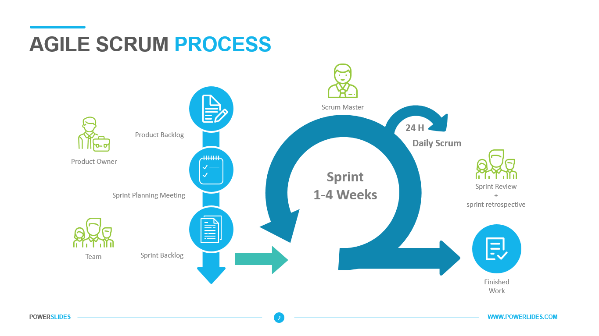

**Figure 3.1. Agile Scrum Methodology**

Developers will use Agile Scrum Methodology. An Agile Scrum methodology relies on iterative development specifically designed to build products faster. This process uses short, predefined development cycles (called sprint or cycles), with each cycle culminating in potentially deliverable features as delivered.

**Process of Agile Scrum**

**Product Backlog** - A product backlog is a prioritized list of work for the development team that is derived from the road map and its requirements. The most important items are shown at the top of the product backlog, so the team knows what to deliver first. The development team does not work through the backlog at the product owner's pace and the product owner isn't pushing work to the development team. Instead, the development team pulls work from the product backlog as there is capacity for it, either continually (kanban) or by iteration (scrum) Radigan (2022).

The developers will list all the requirements and features of the system that are needed for the development. This process can lead to better decision making and it helps the developers to estimate, refine, and prioritize everything in their to-do list for the development of the system. The product backlog is useful in ensuring the team works for the valuable features, fixing the most important bugs and also doing other important work critical for the product development.

**Sprint Planning Meeting** - A sprint planning meeting is when the scrum team meets to decide on which outstanding issues will be addressed in the next sprint or cycle. So, before starting the meeting, the developers will evaluate the team’s ability, review the overall timeline of the project (if there is a deadline), and be ready to act based on the insights that will be gained from the previous sprints.

**Sprint Backlog** - In the sprint backlog, the developers will list all the tasks that will need to be completed to complete the project. During the sprint planning meeting, the team will review this backlog to see what needs to be done and decide what will be going to do next to keep the project on track. Any items that are not completed in the previous sprints can be moved to the backlog. There will also be new elements that may have emerged during previous sprints. The sprint backlog is a plan by and for developers. This is a highly visible real-time picture of the work the developers plan to do during the sprint to achieve the goal for the development of the system.

**Sprint Review** - The sprint review is a tune-up session that typically takes place on the last day of a sprint. It looks at what went well, what went wrong and what can be done better. Customers, managers and other stakeholders may attend the sprint review, to view “done” increments and provide feedback (Khristich, 2020). The developers will gather to review and analyze the completed work and determine if additional changes or improvements are needed for the development of the system. The sprint review is an informal meeting held at the end of the sprint where the team will show what has been accomplished during the development.

**Sprint Retrospective** - According to Khristich (2020), the retrospective is the final meeting at the end of a sprint, attended by the Product Owner, Scrum Master, and development team. During the meeting, participants discuss what improvements can be made, and how to implement them in future sprints.

The developers will hold a meeting to discuss what went well during the previous sprint and what are needed for the improvement of the development of the system. This is an opportunity for the developers to inspect and create plans for the improvements to enact during the next sprint cycle.

**Daily Scrum** - This is the 15-minute event for the scrum teams’ developers. This phase will involve the reviewing of deliverables and the completed work. It is held at the same time and location every working day of the Sprint to reduce complexity. If the product owner or scrum master is actively working on Sprint Backlog items, they participate as developers (scrum.org, 2021). In this phase, the Scrum team developers will hold a 15-minute meeting to discuss the overall project.

Daily Scrum was considered important for the developers because it improved communication, eliminated other meetings, identified development barriers that needed to be removed, focused and accelerated decision-making, and increased the knowledge of the development team. This is a critical review and a review of the discussion.

**Finished Work** - This is a checklist that will be used by the team to create a common understanding of what is needed to release the finished product. This is the phase wherein the developers will meet the following criteria for the project that they are developing. The developers will make sure that every feature/sprint/release will go through steps to ensure that there are no issues/problems and the most important of all is to ensure the consistent quality and completeness of the project.

**3.2 Requirement Analysis**

Requirements analysis is critical to the success or failure of any system or software project. Requirements should be documented, actionable, measurable, testable, traceable, linked to identified business needs or opportunities, and defined at a sufficient level of detail for system design.

The first step in gathering data is to collect information. Information gathering regarding the state, information about the benefits of herbal plants is the main source of data in the identification of requirements. The developers will use books and magazines on the Internet and analyze some existing studies published on e-books as secondary data sources. After gathering necessary information, the developers will now analyze the problem related to the system. Developers rely on user needs. The developers will thoroughly examine all the requirements necessary to fulfill the desired idea for the development of the system.

**Hardware and Software Requirements**

Every computer software requires specific hardware components or other software resources to exist on a computer. In newer software versions, system requirements increase over time due to high processing power and increased resource requirements. Industry experts believe that this process will play a greater role in modernizing existing IT systems than technological advances.

The set of documents or the documentation that describes the behavior of the system or the software application includes a variety of elements that attempt to define the intended functionality needed by those involved to satisfy the variety of users.

The developers will carefully write down the hardware and software requirements that will meet the expectations of the development system. Information from the hardware and software needed to deploy the software helps the system act as intended.

**3.2.1 Population and Locale of the Study**

This study will take place at the City Health Office, which is located in San Carlos City, Pangasinan. This study will gather information about the medicinal plants including their purposes and usage.

**3.2.2 Data Instrumentation**

The developers will use an online survey questionnaire to gather information. An online survey questionnaire is a set of questions specifically designed to gather information about a target audience or group of online users. Respondents can easily respond by accessing the form via an internet connection. This type of survey is a tool that allows you to get feedback about your product or service and collect data for research through online survey platforms.

**3.3 Data Analysis**

The developers will gather data primarily from the staff of the City Health Office (CHO). The main respondents of this project are the residents of San Carlos City, Pangasinan.

The developers will use different data gathering instruments to acquire valuable and relevant information needed in the study.

**Document Analysis** - The focus of the document analysis should be a critical review, not just interpretation of documents. It is a system of social research and an important research tool of its kind. Documentary work involves reading a large amount of written material.

The developers will undergo a thorough analysis of the Medicinal Plants, the team will search the benefits of these plants and track the location where these plants are available and identify the needs of the respondents to give them a better application in case they need medicines without use of money.

**Internet Sources** - The internet has made finding a topic easier than ever. People that have internet access can simply launch a search engine, type, and click instead of going to the library.

The developers will use internet websites to gather important data related to the study that will be conducted. Many associated studies can be found on many websites that will help the developers to strengthen their points in developing the system.

**Online Survey Questionnaire** - An online survey questionnaire is a set of questions specifically designed to gather information about a target audience or group of online users. Respondents can easily respond by accessing the form via an internet connection. This type of survey is a tool that allows you to get feedback about your product or service and collect data for research through online survey platforms.

The developers will relay an online survey questionnaire to the respondents to gather information regarding the system and to know what they need to expect based on the study that the developers are conducting.

**Use Case Diagram**

The use case diagram is a way to summarize the details of the system and its users. It is usually shown as a graphical presentation of the interactions between different elements in the system.

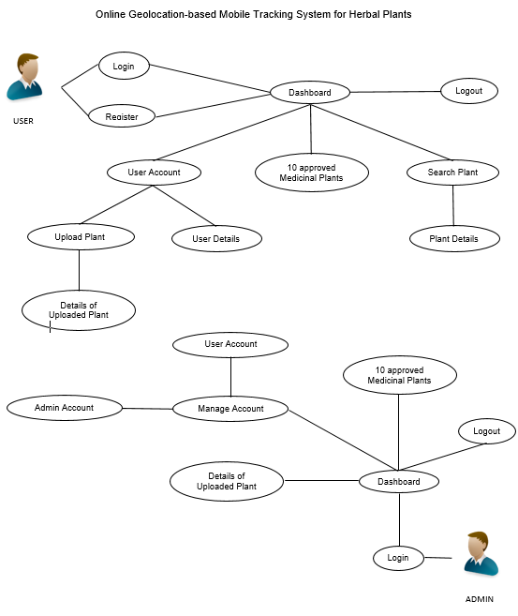

**Figure 3.2**

The information and persons engaged in the development of the system are presented in the figure 3.2. It entails that the administrator can login and will go to the dashboard and can manage the account of both user and admin and can see the 10 approved Medicinal plants and the details of uploaded plants from the user. User can login and if he/she does not have an account, the user can register and will go to the dashboard and can search a medicinal plant then he/she will see the details of it. Also, User can upload a medicinal plant in case there is an available plant in their area so he/she can tag it inside of the account page.

**3.4 Description of Prototype**

According to Volchko(2017), a prototype is an early sample, model, or release of a product built to test a concept or process or to act as a thing to be replicated or learned from.

The developers created a prototype to have a well planned and deployed system without having any issues or problems.

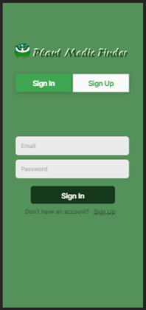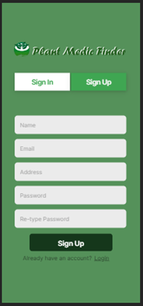



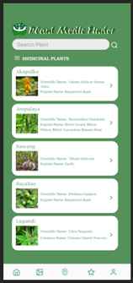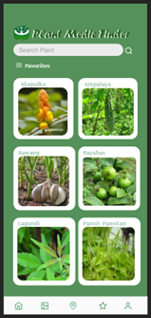



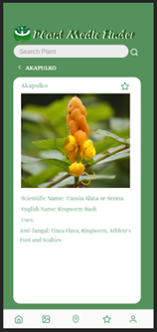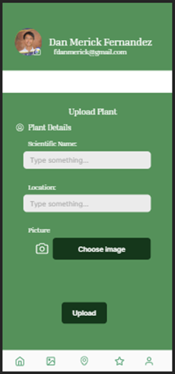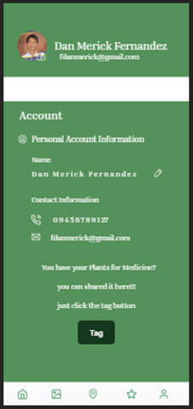



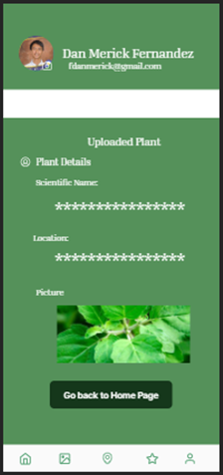



**3.5 The Proposed Implementation Plan**

The proposed implementation plan of Online Geolocation-based Mobile Tracking System for Herbal Plants is as follows. The content of the study should adapt to the user’s requirements. The developers will be responsible to create and develop a proposed implementation plan for the development of the system. The developers will provide with a description of how the information system will deploy, install, and turn into a functional system.